**Team 52 - PartyFreaks – PartyGuard Web Application – Nihitha Reddy Bhimireddy**

**Client:** Jacob Stansbury ([S516098@mail.nwmissouri.edu](mailto:S516098@mail.nwmissouri.edu))

**Roles and Responsibilities:**

1. **Primary Contact:**  Prem Abishai Parise
2. **Client management:**  Nihitha Reddy Bhimireddy
3. **Requirements management:** Lokesh Reddy Pothapu
4. **Data management:** Srichaitanya Peddinti
5. **Issues management:** Sindhuja Pannala
6. **Quality and testing management:**  Spandana Velaga
7. **Communications and documentation management:** Gopinadh Cherupally

**Artifacts:**

1. Added 3 different login pages for 3 types of users in the application.

* Percentage Completed: 100%
* It is on track
* Criticality: Required (Requested by the client to have three different login pages for three different users)
* Below are the links for those we pages

<https://github.com/s525080/PartyGuardWebApp_PartyFreaks/blob/master/src/main/webapp/GuardLogin.html>

<https://github.com/s525080/PartyGuardWebApp_PartyFreaks/blob/master/src/main/webapp/HostLogin.html>

<https://github.com/s525080/PartyGuardWebApp_PartyFreaks/blob/master/src/main/webapp/BasicUserLogin.html>

**Accomplishments:**

* **Hours worked**: 6 hours for developing those login pages and team meetings
* As a client manager, I have contacted our client through email regarding the guard user registration. I have attached the email copy below

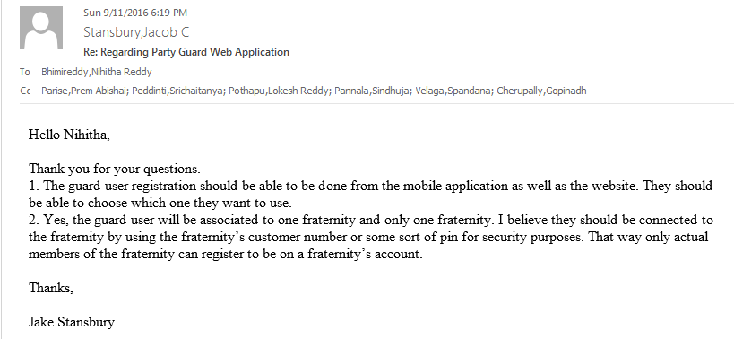

* We had a meeting with other Party Guard teams. We had collaborated with each other in order to finalize regarding our database design and client meeting.
* We had our database design ready for the Web services team to work on.

**Planned work for this week:**

**Week 04:**

* We need to collaborate with Team 54 in order to design guard user registration through web application.
* Implementing the email functionality with validation in the homepage.
* Designing individual profile web pages for guard, basic and host user as their functionalities differ from each other.

**Future tasks:**

|  |  |  |  |
| --- | --- | --- | --- |
| **Week** | **Tasks (Web pages)** | **Status** | **Challenges** |
| Week 03 | Home page | Initial UI screen | Email functionality with validation. |
| Week 04 | Master login page, Basic user login page, Guard user login page | As requested by the client we have designed 3 different web pages | Functionality yet to be implemented. |
| Week 05 &06 | View Customer | Yet to start |  |
| Week 07 | Profile(Guard User) | Yet to start |  |
| Week 08 | Profile(Basic User) | Yet to start |  |
| Week 09 | Change Password(Guard User & Basic User) | Yet to start |  |
| Week 10-13 | Will work on further requirements | Yet to start |  |

**Unresolved challenges that keep you from making progress:**

**Implementing email functionality in home page is challenging.**